Stage 3 – Back in '82, I used to be able to throw a pigskin a quarter mile.
COURSE DESIGNER: Ike Starnes
SCORING: Comstock 14 rounds.
TARGETS: 7 cardboard targets
SCORED HITS: 2 Best hits per carboard will be scored.

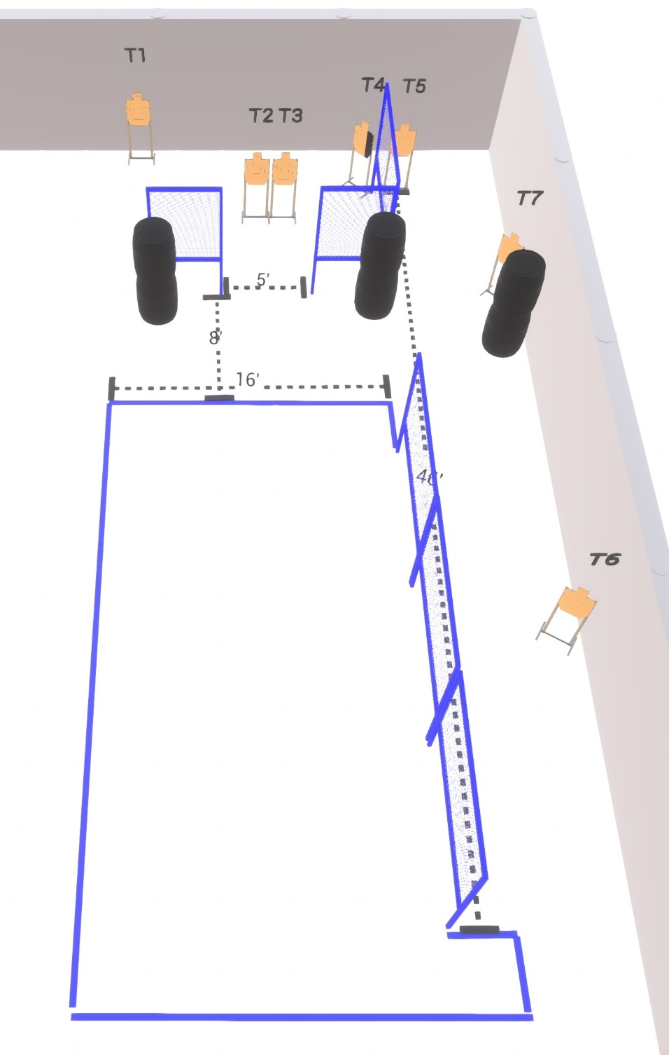

Written Stage Briefing:

Stage 3 – Back in '82, I used to be able to throw a pigskin a quarter mile. - is a 14 round, 70 point, Comstock Course. There are 7 cardboard targets

Starting anywhere
Handgun is loaded and holstered, wrists below belt.
PCC is loaded held in both hands, stock on belt.

On the audible start signal, engage targets from within the shooting area.

USPSA / NROI Range Commands:
- Make Ready
- Are you ready?
- Standby
- If finished, unload and show clear
- If clear, hammer down and holster (Handgun)
If clear, hammer down and flag (PCC)
If clear, cylinder closed and holster (Revolver)
- Range is clear

Setup Notes:
6 Single Wall Stands
3 Double Wall Stands
4 Full Walls
2 Half Wall
7 Target stands / 14 target sticks
6+ Barrels

